Tableau Design Document

# Overview:

The report has two dashboards – Advanced Intelligence Surveillance and News Details. Advanced Intelligence Surveillance shows the insights regarding count of articles categorized by keywords, regulatory agencies and location. News Details shows the summaries of the articles. Users can filter data on the keywords, regulatory agencies, location or date. Dashboard extracts get refreshed every 24 hours with updates on articles from the selected websites through database connection and the dashboard is populated with new and updated data.

# Details of Dashboards:

The workbook contains two dashboards **Advanced Intelligence Surveillance** (Landing dashboard) and **News Details.**

1. **Advanced Intelligence Surveillance:**

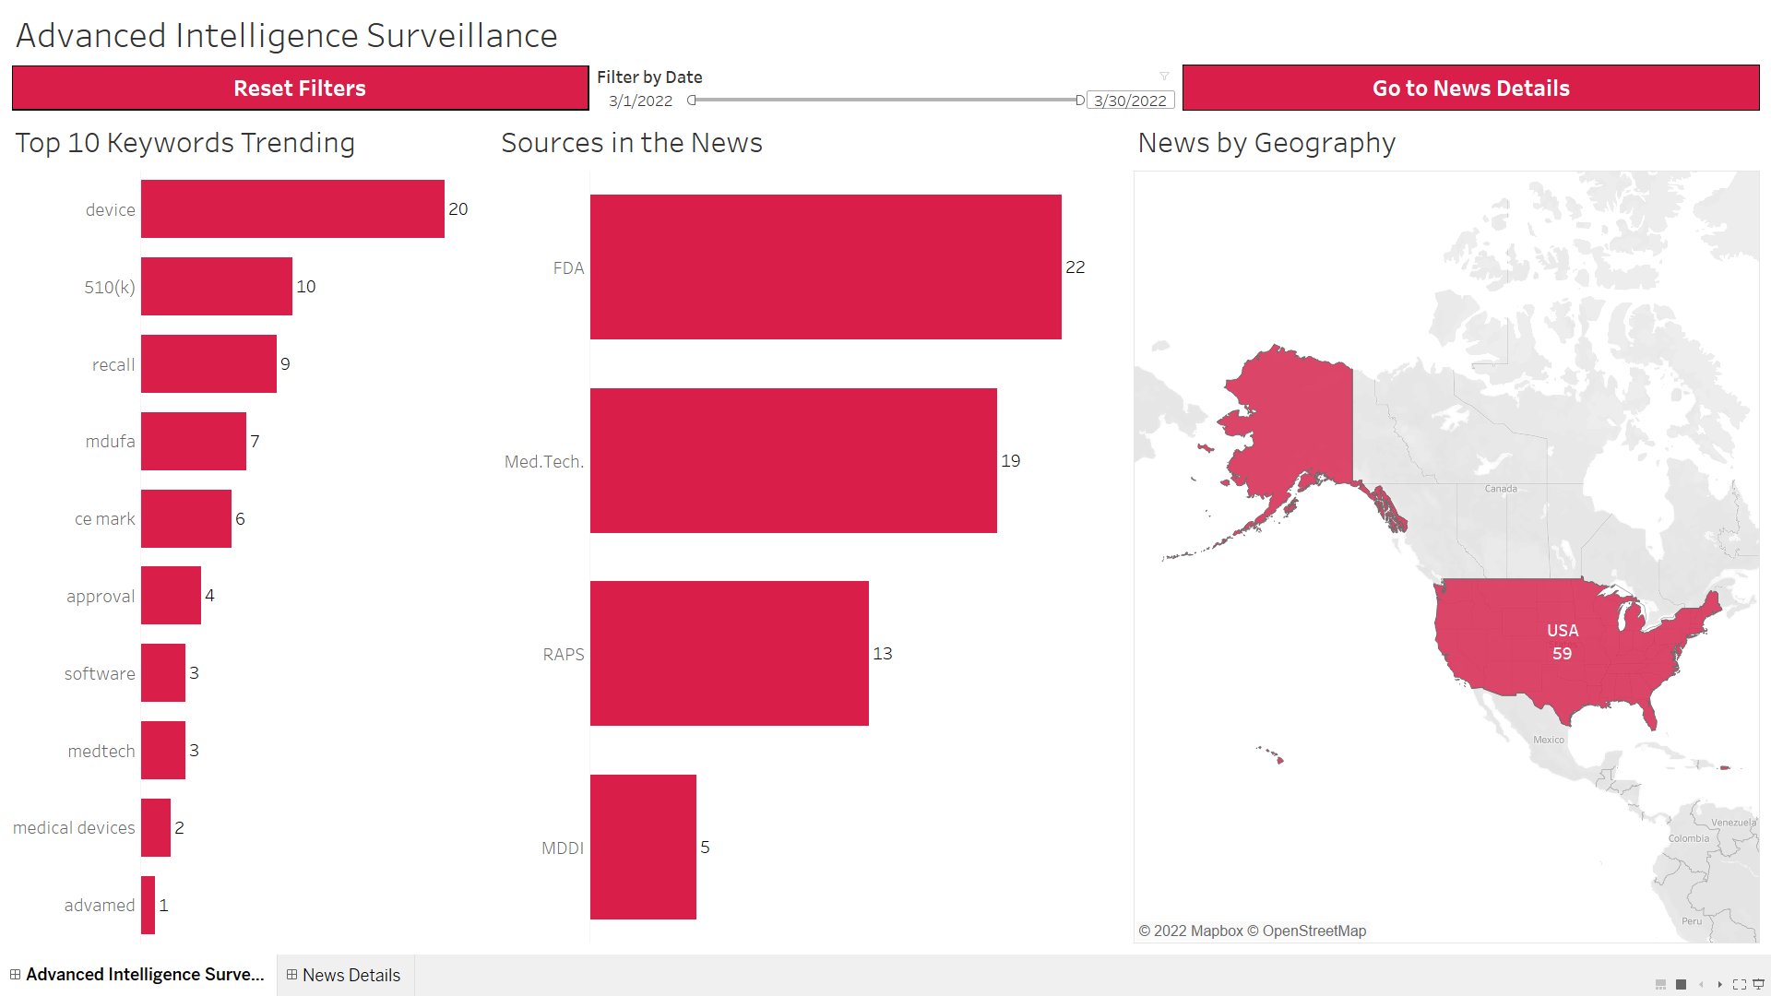

|  |  |  |  |
| --- | --- | --- | --- |
| **Worksheet Name** | **Fields Used** | **Description** | **Viz Type** |
| Top 10 Keywords Trending | * Title * Keyword | It shows the top 10 keywords are shown based on the maximum count of distinct articles associated with the keyword, in descending order. | Horizontal Bars |
| Sources in the News | * Title * Regulatory Agency | It shows the count of distinct articles regulated by the regulatory agency. | Horizontal Bars |
| News by Geography | * Title * Country | It shows the count of distinct articles published the country. | Symbol Maps |
| Reset Filter | Reset Filter | Used as a reset all filters button that will reset all the applied filters on the dashboard. | Text Tables |
| Go to News Details | NA | It is a navigation button that will take the user to the dashboard – **News Details.** | Navigation |
| Filter by Date | Article Published Date | Filter data based on selected date range. | Filter – Range of Dates |

1. **News Details:**

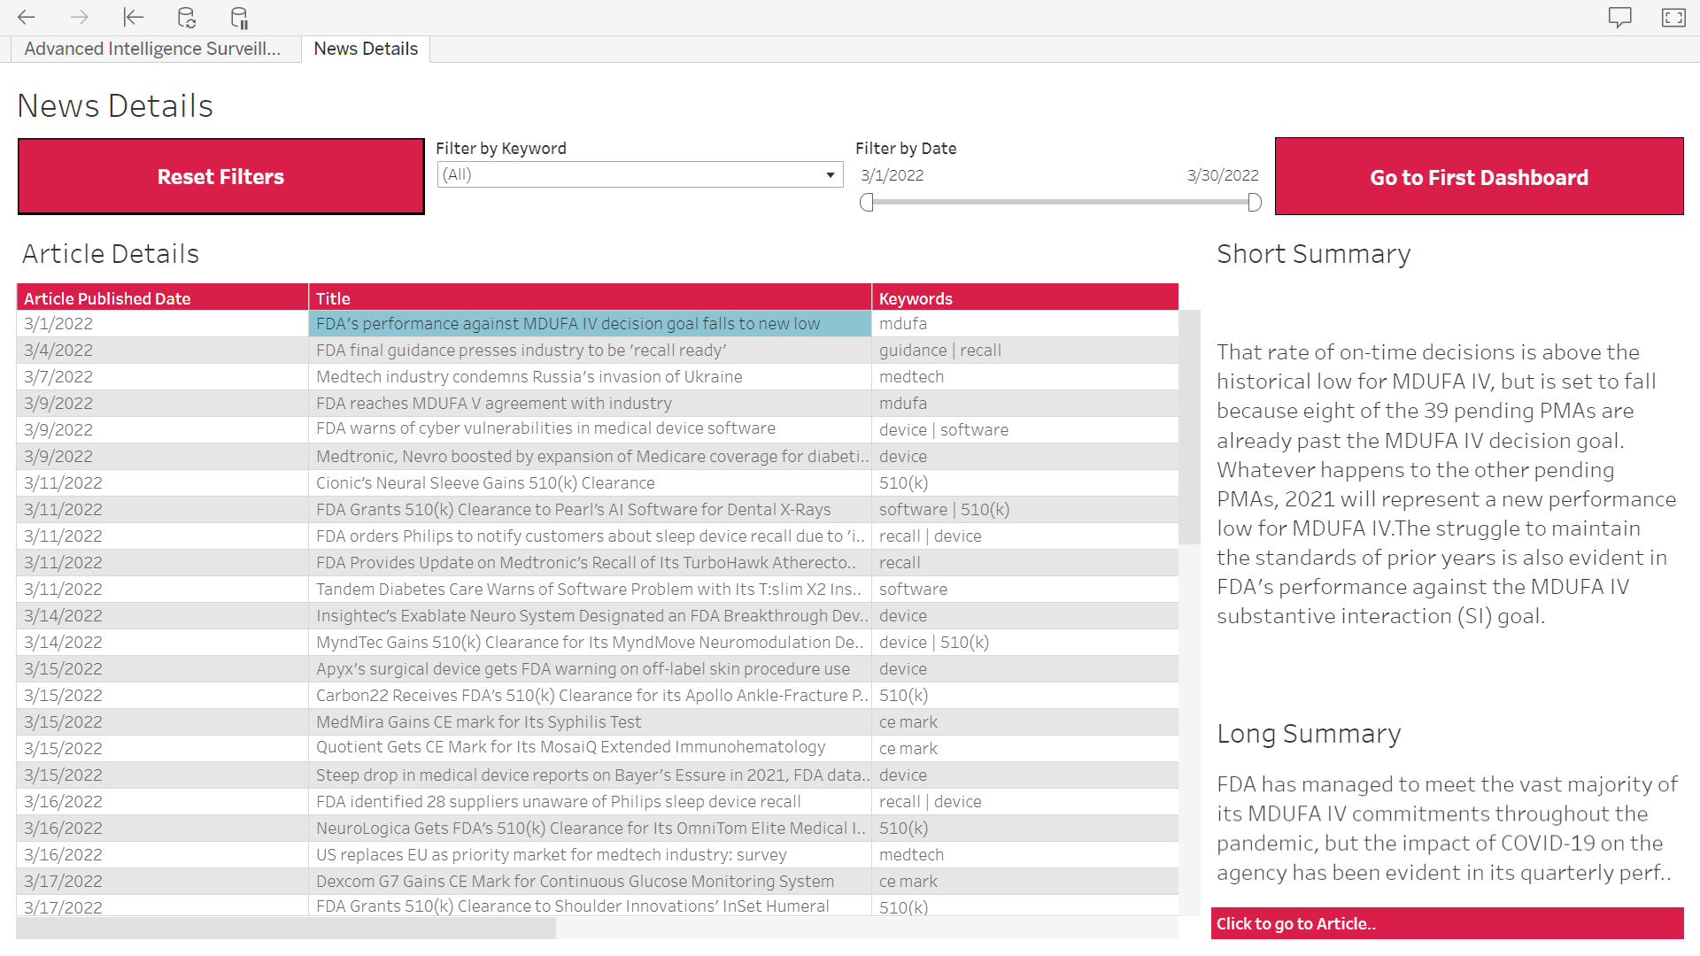

|  |  |  |  |
| --- | --- | --- | --- |
| **Worksheet Name** | **Fields Used** | **Description** | **Viz Type** |
| Article Details | * Title * Keywords * Article Published Date * Row Number * Blank | It shows date on which the article was published, title of the article and all the keywords associated with the article in a tabular format. | Text Tables |
| Short Summary | * Short Summary | It shows a short summary of the article. | Text Tables |
| Long Summary | * Long Summary | It shows a long summary of the article. | Text Tables |
| Article URL | * Article URL | It shows a clickable URL of the article which on clicking take the user to the actual article on the website it was published. | Text Tables |
| Reset Filter | Reset Filter | Used as a reset all filters button that will reset all the applied filters on the dashboard. | Text Tables |
| Go to First Dashboard | NA | It is a navigation button that will take the user to the dashboard – **Advanced Intelligence Surveillance**. | Navigation |
| Filter by Date | Article Published Date | Filter data based on selected date range. | Filter – Range of Dates |
| Filter by Keyword | Keyword | Filter data based on selected keyword/s. | Filter – Multiple Values (dropdown) |

# Link to Server:

<https://idea-ts-stage.astellas.net/#/projects/56>

|  |  |
| --- | --- |
| **Dashboard Name** | **Server Link** |
| AIS_GRIP | <https://idea-ts-stage.astellas.net/#/workbooks/298?:origin=card_share_link> |
| AIS - Quality | <https://idea-ts-stage.astellas.net/#/workbooks/287?:origin=card_share_link> |

# Data Source Details:

* Microsoft SQL Server connection is established to extract data from Database.

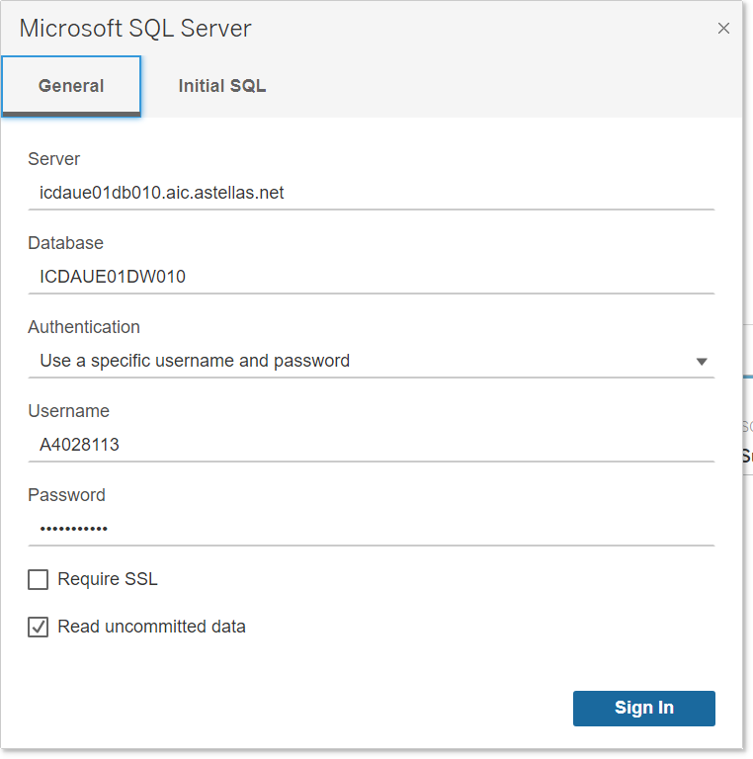

* Tables used:

1. Article_Details
2. Source_Website_Details

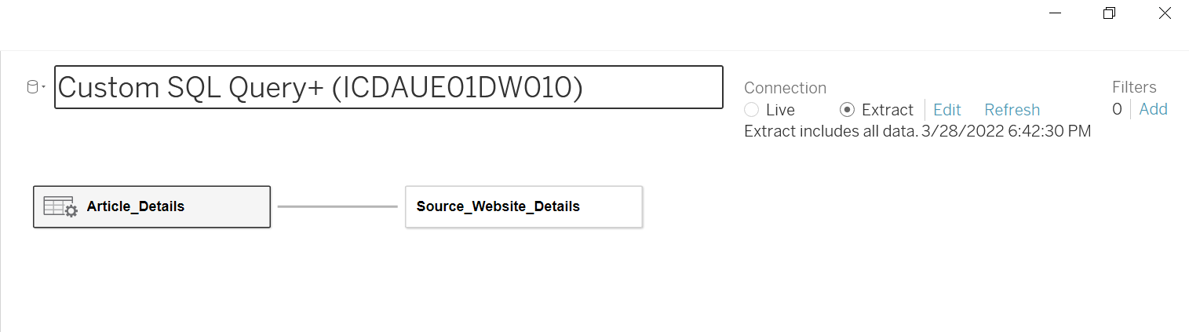

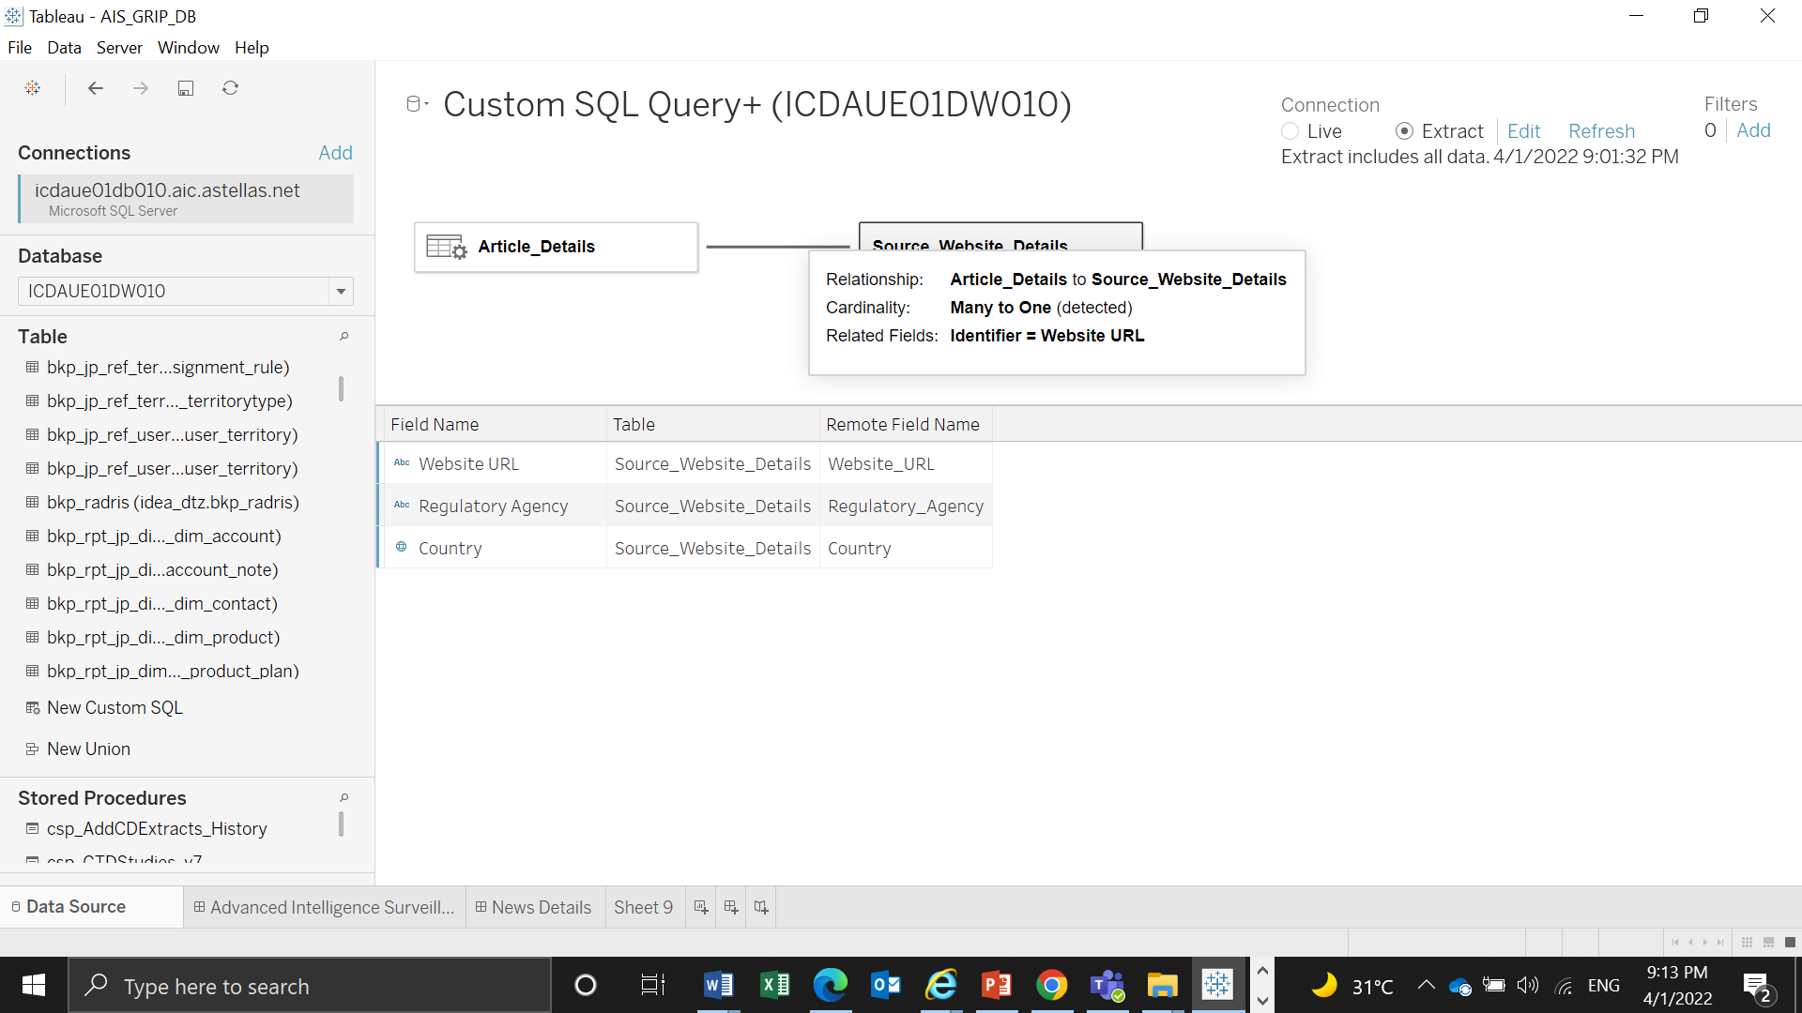

|  |  |  |  |
| --- | --- | --- | --- |
| **Table Name** | **Data Source Type** | **Source** | **Relationship** |
| Article_Details | Extract | SQL Server | Article_Details to Source_Website_Details  Related Fields:  Identifier = Website URL |
| Source_Website_Details | Extract | SQL Server | Article_Details to Source_Website_Details  Related Fields:  Identifier = Website URL |

* Custom SQL Query is applied on the table **Article_Details** to split **Keywords** column which contain multiple keywords separated by **‘|’** symbol, into multiple columns which will contain a single keyword.

SELECT [Article_Details].[Identifier] AS [Identifier],

[Article_Details].[Title] AS [Title],

[Article_Details].[Article_URL] AS [Article_URL],

[Article_Details].[Article_Published_Date] AS [Article_Published_Date],

[Article_Details].[Keywords] AS [Keywords],

[Article_Details].[Long_Summary] AS [Long_Summary],

[Article_Details].[Short_Summary] AS [Short_Summary],

value as Keyword

FROM [ais_poc].[Article_Details] [Article_Details] CROSS APPLY STRING_SPLIT(Keywords, '|') as New_Keyword

* Table Fields Details:

1. Article_Details:

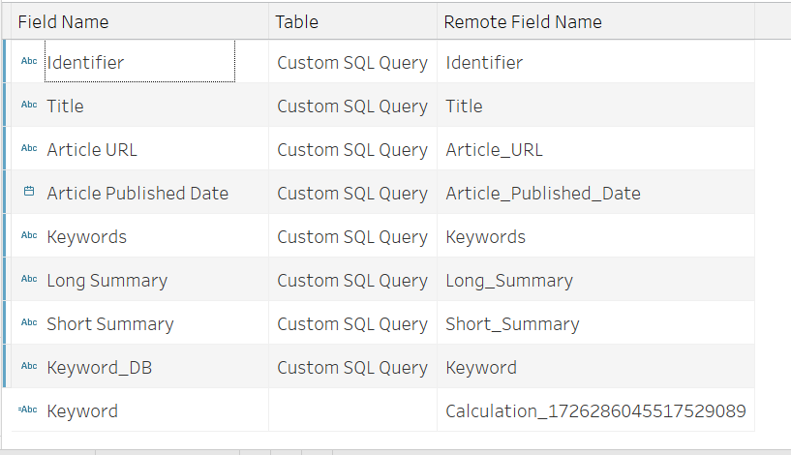

1. Source_Website_Details:

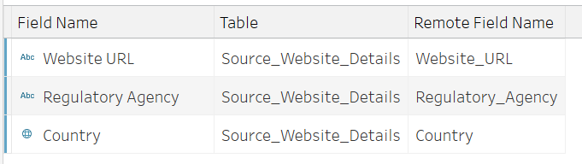

* List of Calculated Fields:

|  |  |
| --- | --- |
| **Name of Field** | **Formula Used** |
| Blank | '' |
| Keyword | TRIM([Keyword_DB]) |
| Reset Filter | 'Reset Filters' |
| Row Number | INDEX() |